VetBuds of North Georgia – 2025 Annual Report
In 2025, VetBuds of North Georgia continued its vision of Veterans Supporting Veterans by providing direct assistance, fellowship, and critical services to those who served our nation. Through the dedication of our members and the strength of our community partnerships, we delivered meaningful support across Georgia. Accomplishments from the year include:
2025 Highlights
- Awarded six $1,000 grants to Georgia State University student veterans
- Increased to 55 the total number of vehicles donated through our Vehicles for Vets program
- Provided essential relief to homeless veterans, including vehicle repairs, clothing, hygiene items, and food
- Delivered emergency shelter assistance to four veterans in crisis
- Installed safe passages and mobility aids in the homes of disabled veterans
- Partnered with local veteran support groups to remove dangerous trees from two veterans’ homes, including a Habitat for Humanity home for a disabled veteran
- Led a team of volunteers to clean up the yard and carport of a disabled veteran in Sandy Springs, helping him resolve code-enforcement issues with the city
- Offered licensed mental health counseling to veterans
- Provided personal financial literacy counseling by a licensed professional advisor
- Provided funeral escorts to honor deceased veterans and support their families
- Assisted veterans navigating Department of Veterans Affairs services
- Conducted a major fundraising event that generated over $42,000 to support our programs
- Drove disabled veterans to VA and private medical appointments
- Collected and distributed food items at American Legion Post 201 in Alpharetta
- Supported veteran-owned small businesses
- Continued to improve our website vetbuds.us
- Published a monthly newsletter featuring VetBuds activities and community partners
- Strengthened veteran engagement across social media platforms with consistent updates on Facebook, Instagram and LinkedIn
- Led a Wreaths Across America effort to place wreaths on veteran gravesites at Georgia National Cemetery
- Collaborated with multiple nonprofit veteran support organizations to expand our reach including About Face USA, Cherokee County Homeless Veterans Program, Genesis Joy House, Operation Rally Point, The Warrior Alliance, St Benedict Knights of Columbus, Catholic War Veterans of Atlanta and Pathlight Counseling

Looking Ahead to 2026
We invite all honorably discharged veterans and active-duty service members to join us as we continue addressing the challenges facing our veteran community.
Our primary group meets every third Wednesday at 0730 hours for breakfast at:
Uptown Café
9850 Nesbit Ferry Road
Johns Creek, Georgia
VetBuds members also lead additional groups in West Cobb and Cherokee County, extending our support across the region.
About VetBuds
Mission: VetBuds is a group of military veterans whose purpose is to provide assistance to other veterans.
Vision: Veterans Supporting Veterans
Website: vetbuds.us
All VetBuds services are provided by volunteers who accept no financial compensation.
VetBuds is a 501(c)(3) nonprofit organization.



OUR SPONSORS

MOLD INSPECTION
AIR QUALITY TESTING
DEMOLITION FREE MOLD TREATMENT
VetBud - Paul Romanick
404-295-6333
VetBud - Wes Stansbury, GRI, CRS
ASSOCIATE BROKER I REALTOR®
770-597-5441 Direct
Wes@WesStansbury.comcom


Patriot Towing Services was founded in 2015 and is Veteran Owned and Operated by VetBud - Jason Robbins and Bill Atkins. We are a full service residential and commercial Towing Services provider offering a full array of Towing Services, Hauling Services, Roadside Assistance Services, Winch Outs and Accident Recovery Services.
Patriot Towing Services
2770 Airport Drive
Ball Ground, GA 30107
770-345-8888

JB is a seasoned financial and benefits professional with over 30 years of experience in Personal Finance, Financial Planning, Healthcare, Medicare, and Retirement Benefits.
JB began his career in the U.S. Air Force, where he dedicated 20 years of service all within the financial sector.
If you or anyone you know, is in need of expert guidance in any of these areas, JB would be happy to offer assistance.
Serving Metro Atlanta and Surrounding Regions
VetBud - John Brian (JB) Burnett - 404.536.1194


“Because sometimes you need a NINJA”
VetBud - Howard R. Stentz III
President / CEO
770-331-358036
hrs@howste.net
IT and WEB Services
“Howard has donated his Company’s time and resources bringing life to the VETBUDS much-needed website”.
VetBuds Merchandise

Click on the Logo above to order VetBuds merchandise
Want something not shown. Contact them and request the merchandise with the VetBuds emblem

VetBuds embroidered merchandise is available for purchase. You can order clothing and hats directly from the site and have it shipped or pick it up at their shop.
If you have a need for Screen Printing or Embroidered items, we encourage you to consider 92 Threads for your next project.
615 Hembree PKWY Suite 200, Roswell, GA 30076
Phone 770 – 645 – 1390
“Veterans helping Veterans”

Reach Out To Us
888.266.0914
Avery Partners supplies world class Consulting, Outsourcing and Staffing services across multiple industries. Our recruiters are experts in their fields and deliver 2nd to none services for our clients.


VetBud - Tom Burgess
Owner
Two Locations to serve you
10879 Jones Bridge Rd | Alpharetta GA 30022
T: (678) 539-8934 FAX: 678-867-0903
5690 Bethelview Road | Cumming, GA
T - 470 253-7376 FAX 770-406-8379

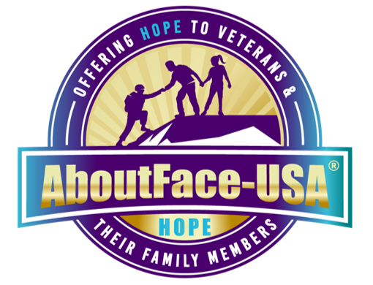
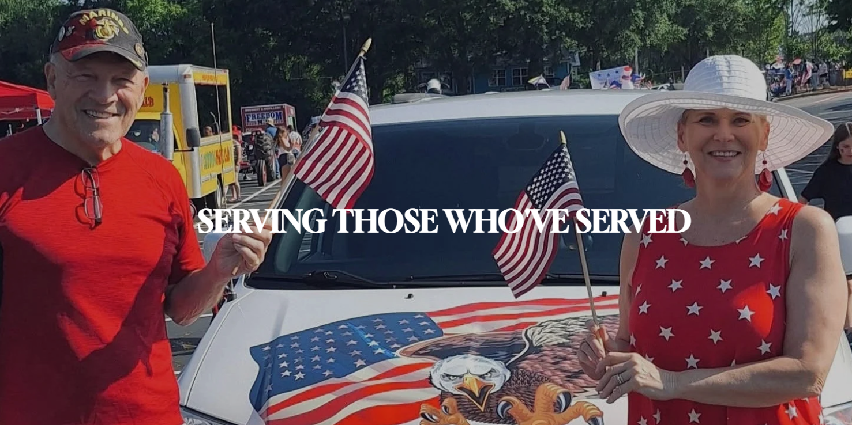
At AboutFace-USA®, we empower veterans and their families with the resources, programs, and support they need to overcome challenges and thrive. By addressing mental health, fostering whole-health wellness, and creating innovative opportunities like community farming, we are building a foundation for resilience, growth, and lasting change.

VetBuds - Joe & Carol LaBranche
AboutFace-USA®
188 Tri County Plaza, Cumming, Georgia 30040
1 888-766-0222

Dedicated to helping Veterans in Crisis
There are thousands of Veterans in our country that are in mental and physical distress due to service-related trauma. At Operation Rally Point, we repay their sacrifices by providing them with the support they need when they are in crisis.
VetBud - Brandon Watts - 678 – 276 – 6374

Remember the fallen. Honor those who serve. Teach the next generation the value of freedom. Our volunteers are the beating heart of the program and work year-round to share this important mission and inspire others to join.
VetBud – Jerry Tiarsmith


The mission of Man in the Mirror is to equip Christian men around the world to engage in meaningful relationships that changes lives and builds the kingdom of God.
VetBud - John Davis 678 – 607 - 5601



Improving quality of life for homeless female veterans

The number of homeless female veterans has tripled in the last ten years.
That number continues to rise at an alarming rate as more women enter military service.
VetBud - Mark Clark

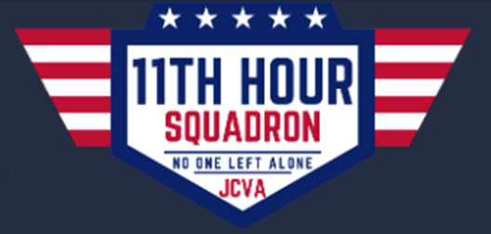

Spend some time doing quieter work and show love to our fellow Veteran. Please consider comforting our brothers and sisters in their final hours by joining our group. It makes a difference for them to spend their last moments with someone who is kind and caring. It’s comforting to family members, knowing that their loved one isn’t alone when they pass away.
VetBud - JoAnne Melear 770 - 598 – 8386



Helping Warriors Navigate to Success after Service
Our mission is to improve the quality of life for service members, Veterans, and their families through a total care network of Veteran support organizations.
VetBud - Mark Eister V. P. Operations 404 – 210 – 1776

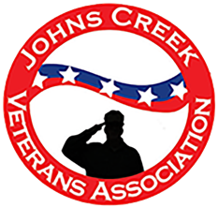

“The JCVA shall have as its purpose the promotion of the welfare of the City of Johns Creek U.S. military veterans, the U.S. veteran community in the surrounding areas, and the support for as well as collaboration with other veteran-based organizations. A further purpose shall be to raise awareness within the Johns Creek community to understand and appreciate the contributions veterans made and those that they continue to make on behalf of their community and country. “
VetBud – Keith Bogle



11045 Parsons Road, Johns Creek, GA 30097
770-442-5903



Hypnotherapy, an Ancient Art…a New Approach
VetBud - Alton M Reynolds, LPC, M. ED, CI.H
1864 Independence Square – Ste A
Dunwoody, GA 770-390-0444

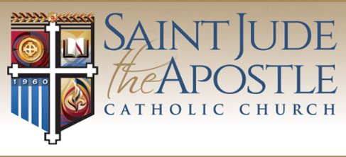
https://judeatl.com
Saint Jude the Apostle Knights of Columbus
7171 Glenridge Drive - Sandy Springs, GA 30328
770-394-3896
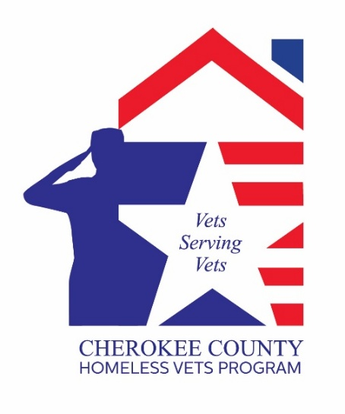
VetBud - Jim Lindenmayer
jlindenmayer80@gmail.com
Joshua Lear - usmarine1341@gmail.com
(678) 983-7590

We serve veterans in Cherokee County Georgia by providing help with food, limited housing, clothing, Veterans Affairs claims, home of record, and other support.

SERVING THOSE WHO SERVED
Veterans & Families — You’re Not Alone!
FREE, Grant-Funded Support for Substance Use & Mental Health
📍 WHO: Veterans & families facing opioid, stimulants, alcohol, or other substance use.
💬 WHAT:
- ✔ VA Benefits & Compensation Guidance
- ✔ FREE Counseling for PTSD, Trauma, Mental Health
- ✔ Peer Support & MAT (Medication-Assisted Treatment)
- ✔ Family & Child Counseling
📌 WHERE: Pathlight Counseling - 4390 Earney Rd, Ste 140, Woodstock, GA 30188
💡 WHY: Your service, your recovery, you are your family's lives—they all matter.
📞 CONTACT: Scott Brown (USMC Veteran, Iraq Veteran) – (470) 648-1528
🌐 pathlightga.com

“THANK YOU”
UPTOWN CAFÉ
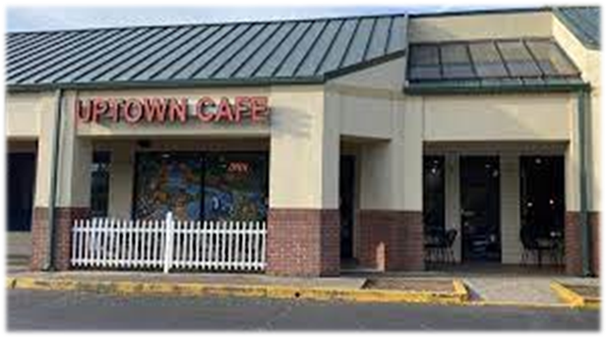
Uptown Café
9850 Nesbit Ferry Rd, Roswell, GA 30022
770-552-5775

